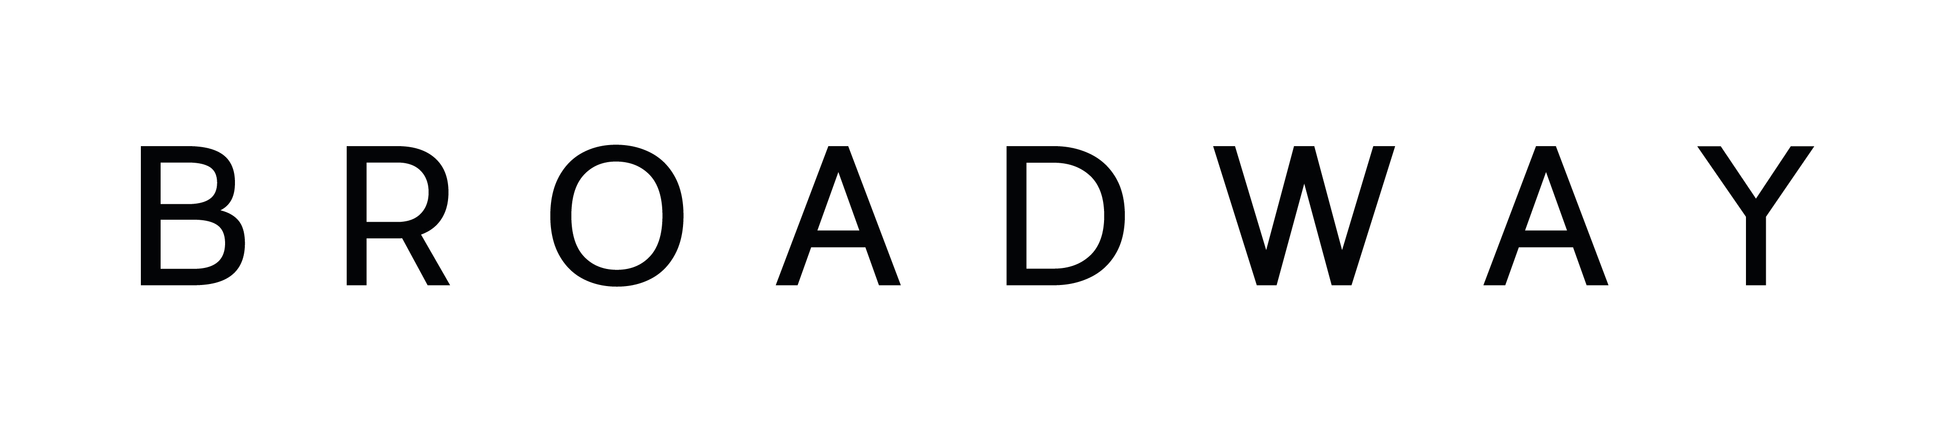
Job Description
Job title: Café Bar Supervisor
Reporting to: Café Bar & Kitchen Manager
Staff responsible for: Customer service assistants
Functional responsibility: To support the Café Bar Manager in ensuring the efficient and profitable operation, and effective management, of the Café Bar and catering function.

Hours worked: up to 40 hours per week
Salary Grade: £11.42 per hour
Date issued: July 2023
Commitments & Measures | Job objectives and outcomes
Commitment 1  Measures | Support the Café Bar Manager in operating the Café bar in line with the agreed annual budget, with effective and regular communication always  - Help and support the Café Bar Manager to ensure GP% is maintained at budgeted level.  - Be aware of and assist in monitoring labour costs weekly/monthly to achieve budgeted cost.  - Regular communication with line managers and staff, using the most appropriate channels.  - Support in organising Café Bar meetings on a regular basis and attend any management meetings where required.
Commitment 2  Measures | Work to maintain revenues at budgeted levels or higher  - Support the Café Bar Manager in the design and delivery of a range of initiatives to increase bar revenues.  - Maintain an awareness of competitor pricing and product and apply this knowledge to increase and improve Broadway’s revenue.  - Support the Café Bar Manager in the planning and delivery of promotions and special events, alongside the assistance of the programme and marketing teams.
Commitment 3  Measures | Ensure a high level of customer service and customer satisfaction  - Encourage and enforce a culture of excellent customer service and care.  - Ensure all decisions are made with the needs of the customer in mind.  - Assist the Café Bar Manager in setting high customer service standards for the service of food and beverages, and the delivery of private events, ensuring that these standards are adhered to.  - Support and help deliver service training and product knowledge for all new starters.

Commitment 4  Measures | Take responsibility, alongside the Café Bar Manager, for being aware of, and enforcing, legal regulations on the sale of alcohol, stock control and product offering  - Ensure Broadway adheres to government regulations for the sale of alcohol, and weights and measures.  - Ensure that no alcohol is served to any person under the age of 18, and that all persons looking 25 years or under are appropriately checked within the Café Bar areas.  - Assist the Café Bar Manager in the careful selection of a range of quality beverages and snacks in keeping with the Broadway brand and customer preferences.  - To place the weekly drinks orders (in the absence of the Café Bar Manager).  - Ensure a line clean is completed as often as required to maintain the high quality of all draught products.  - Support the Café Bar Manager in control and responsibility for all stock, ensuring stock is effectively rotated and wastage is minimised and recorded.  - Work with the Café Bar Manager to constantly review prices, products, and suppliers to ensure the best price and quality.
Commitment 5  Measures | Management and supervision of direct reports  - Support the Café bar Manager in maintaining a well-trained and experienced team of motivated staff.  - Ensure the suitable level of staffing is maintained, taking cost, business levels, events, and customer service into consideration.  - Support the Café Bar Manager in cross training staff in all areas wherever possible to allow flexible working.  - Identify and recognise staff performance, and provide recognition, feedback, or discipline where necessary.
Commitment 6  Measures | Ultimate responsibility for cash handling and for building security when on duty  - Take responsibility for the safety and correct handling of all cash in bar tills and safe.  - Complete the daily cash up at the end of the day (when on duty), ensuring set procedures for cash handling and banking are followed.  - Ensure all monies balance correctly with EPOS sales across each week, and that all revenues are transferred to the bank in a timely manner.  - Ensure the correct level of change is always available, that floats are balanced daily, and that any change orders are accurate on collection from the bank.  - Complete a final building check and ensure the building is empty, securely locked, and alarmed when ending any night shift as the duty manager.
Commitment 7  Measures | Assist in the production of additional revenue through private events, and ensure the service quality  - Liaise with the Events Coordinator and Café Bar Manager regarding all upcoming events.  - Attend the weekly operations meeting in the absence of the Café Bar Manager and ensure all relevant event details are confirmed and discussed and shared with the Café bar team.  - To be responsible for all private bookings (when on duty) ensuring guests receive the highest levels of service and hospitality throughout their event.
Commitment 8  Measures | Adhere to health and safety of catering hygiene regulations  - Support the General Manager/Café Bar Manager in ensuring a high quality of Health and Safety, cleanliness and food hygiene in all catering areas.  - Supervise a strict cleaning rota for all bar areas.  - Ensure all work carried out in the Café bar in compliance with all statutory legislation i.e. Fire, Hygiene, and Health and Safety.
Commitment 9  Measures | General requirements  - Be committed to, and actively involved in, excellent customer service and best practice in both internal and external communications.  - Manage own workload effectively.  - Able to use Microsoft Outlook, Excel and Word.  - Attend appropriate Broadway meetings.  - To receive supervision and appraisal and be committed to own development.  - To be committed to and work within Broadway policies and procedures.  - Undertake any other tasks as deemed appropriate by the line managers.

